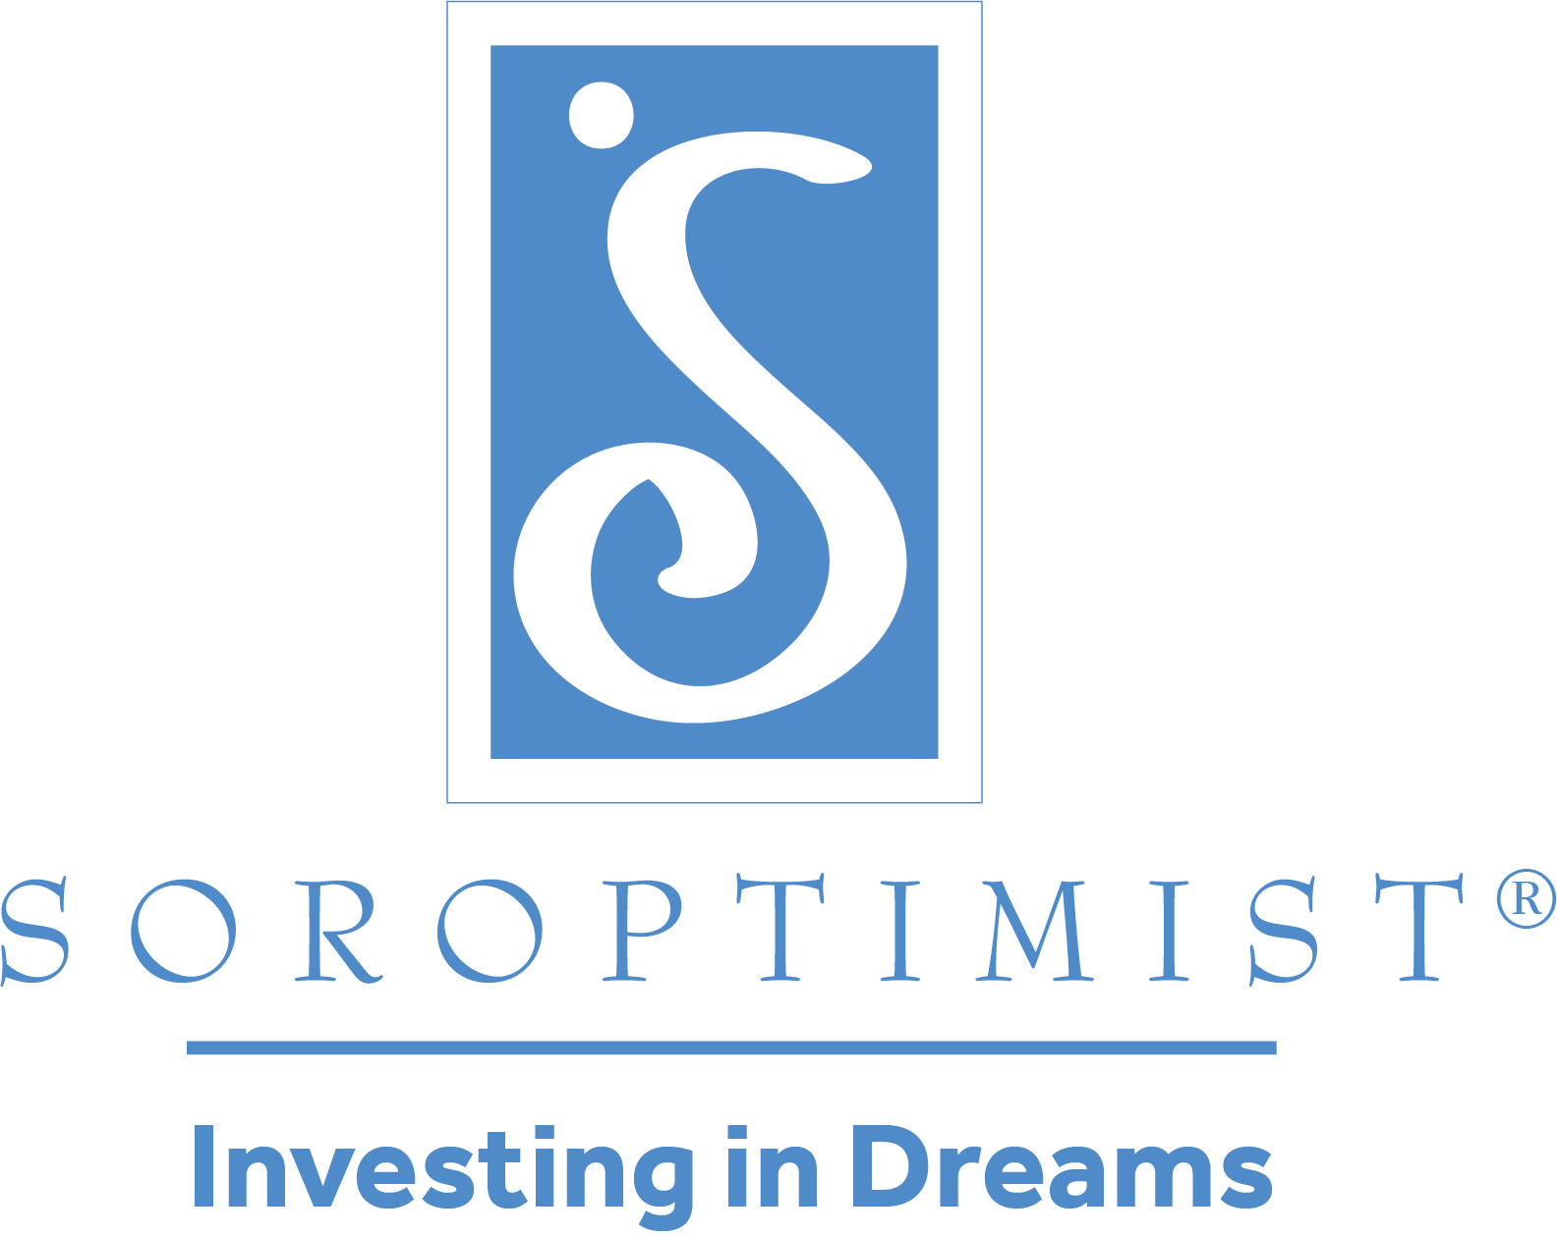
Soroptimist International of Truckee Meadows

“Unsung Hero” Nomination Form

2022

Soroptimist International of Truckee Meadows honors children in our community whose acts or service reflects the higher ideals of the human spirit. An “Unsung Hero” is a child in 1st through 8th grade who demonstrates kindness, generosity, concern for others, humility, courage, perseverance or the ability to overcome hardships in a way that inspires others and makes the world a better place. The recipients will be awarded at our annual “Thanks to Youth” luncheon on May 26th, at the Atlantis Resort and Casino.

This form can be filled out and emailed to the email address below or printed and mailed to the address below. Your nomination form must be postmarked by January 28, 2022 if mailed or received via email no later than January 28, 2022 in order to be eligible.

Soroptimist International of Truckee Meadows
Attn: Unsung Hero Award
P.O. Box 20125Reno, NV 89515

OR you may email the entire packet to edyouth@sitmnv.org

Nominee Information:

Name: Age:

Phone: Email:

Street Address:

School:
City: Zip:

Grade:

Page 1

Explain what it is about this nominee that qualifies him/her to be an “Unsung Hero. Feel free to attach any relevant documents, articles, recommendations. Attach extra pages, if necessary, but write on one side only, please).

Page 2

What impact has the child had on family and community? Has this child had to overcome any obstacles?

Nominator’s Name:

Relationship to Child:

Nominator’s Address:

Best way to contact Nominator:

Email: Phone:

I agree to accompany my nominee to the awards luncheon, as a guest of Soroptimist.

_____________
Date Signature of Nominator

Page 3

